3-Month Python Challenge: Progress Report

Chapter 1: Getting Started
In this chapter, I learned how to install Python on my local machine (Lenovo ThinkPad X1 Carbon running Kali Linux). I also installed a text editor, and in my case, I chose PyCharm. Additionally, I learned how to check if Python is installed on my Kali Linux machine.

Steps to Get Started:
- Python Version:
  - a: On Linux:
    - Open the terminal and run:
python –version
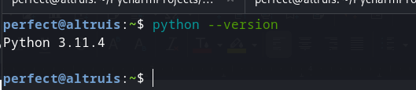

For a specific version:
1. python2 –version
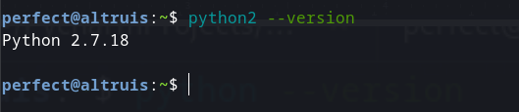

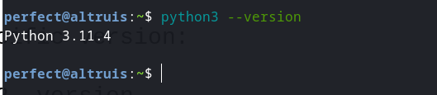

If Python is installed, you'll see the version information.
To enter the Python prompt, run:
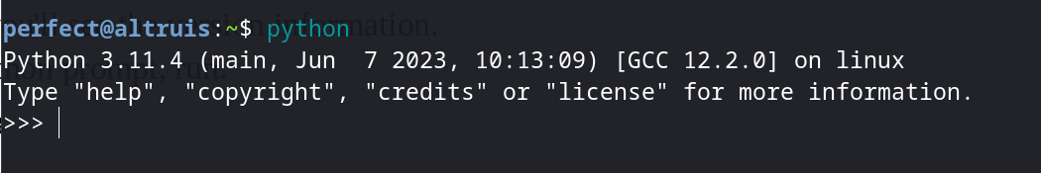

  - If successful, you'll see a Python prompt.
b: On Windows:

2. Python Installation:
- Follow the steps outlined in the README.md file for your Operating System if Python is not installed.
- Text Editor Installation:
Install a text editor. In my case, I recommend PyCharm. Follow the instructions in the README.md file.
- Final Touches:
- Open your text editor, create a file with a .py extension, and write:
print("Hello World")
  - In PyCharm, press Shift + F10 to see the output on the console.

Important Notes:
- Ensure Python and the text editor are correctly installed before proceeding.
- This guide assumes you have basic knowledge of using the command line.

